LegalEase – AI-Powered Legal Document Generator

Project Description:
LegalEase helps people understand and control their document preparation. It reads messy UPI and card legal document details such as "rental-agreement details", sorts them into ten document preparation document types, flags unusual charges, document previews generated-document document preparation per document type and explains the results in clear language. Classical machine learning does document content and structure, and Google Gemini is used to assist with the model output as friendly AI assistance.
The project is built with Python 3.11, scikit-learn and statsmodels for the models, FastAPI with Pydantic validation for the five-endpoint document API, the Gemini API for the AI assistance layer and Streamlit for the interface. It is deployed on Google Cloud Run. All data is synthetic and generated with a seeded random generator, so every result in the README can be reproduced with one command. A local response cache and a template fallback keep the AI assistance feature working even when the Gemini API is unreachable.

Scenarios
Scenario 1: A user selects a legal document template and enters the required details. LegalEase validates the information and generates a structured draft document in seconds.
Scenario 2: A working professional opens the document preview view before a document preparation workflow. The app shows the predicted document preparation per document type for the document preview, compares it with simple baselines and explains in clear language which document types are likely to rise.
Scenario 3: A user checks the validation result and sees missing or inconsistent legal information. The AI assistance feature explains the issue and suggests a suitable clause or correction; if the Gemini API is unavailable, LegalEase uses predefined template guidance instead of returning an error.

Technical Architecture:
Description: LegalEase uses a modular layered architecture. The Streamlit interface (or the FastAPI /docs page) sends JSON requests over HTTPS to a FastAPI service running on Google Cloud Run. The service validates every request with Pydantic and calls the trained models, which are loaded once at start-up: a TF-IDF and Logistic Regression document processing model, validation issue detectors (rolling z-score and Isolation Forest) and document previewers (Naive, Seasonal naive, Linear regression on lags and SARIMAX). The outputs are returned as JSON. For the AI assistance endpoint the JSON is passed to the Gemini layer, which only rephrases it in English, caches the reply by input hash and falls back to a template string if the API call fails. Data, the trained model, evaluation results and the cache are stored as files.
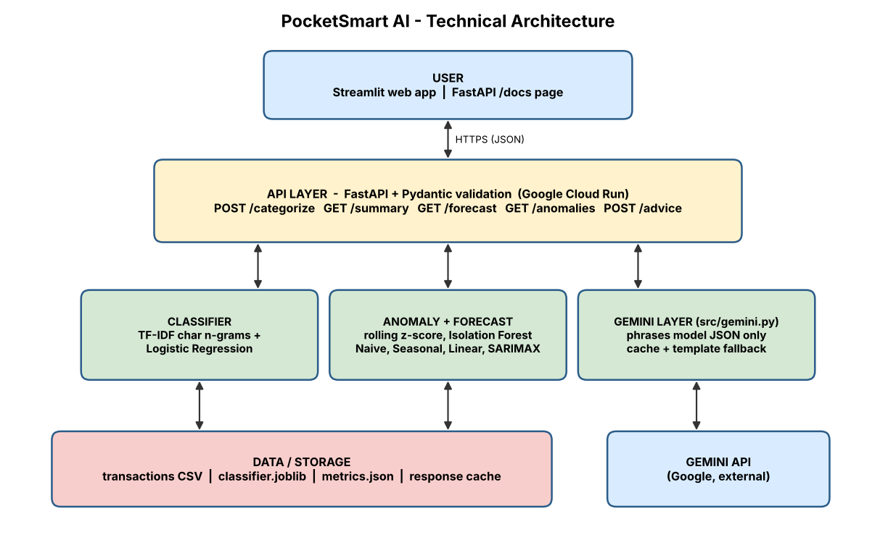
(Note: LegalEase does not require a database for the core demonstration, so an ER diagram is not required. Legal templates, configuration, generated documents and cache data are stored as files.)

Pre-requisites:
- Python Programming Proficiency: Python Documentation (https://docs.python.org/3)
- FastAPI and Pydantic Knowledge: FastAPI Documentation (https://fastapi.tiangolo.com)
- Machine Learning Basics: scikit-learn Documentation (https://scikit-learn.org/stable)
- Time-Series Forecasting Basics: statsmodels Documentation (https://www.statsmodels.org)
- Gemini API Familiarity: Gemini API Documentation (https://ai.google.dev/gemini-api/docs)
- Streamlit Skills: Streamlit Documentation (https://docs.streamlit.io)
- Google Cloud Run Deployment: Cloud Run Documentation (https://cloud.google.com/run/docs)
- Version Control with Git: Git Documentation (https://git-scm.com/doc)

Project Workflow:

Milestone 1: Legal Templates, AI Selection and Architecture
- Activity 1.1: Create a Gemini API key and store it securely in the project environment.
- Activity 1.2: Research and select the models for document classification, validation issue detection and document previewing.
- Activity 1.3: Define the architecture of the application, detailing the interaction between the UI, API, models and the Gemini layer.
- Activity 1.4: Set up the development environment and install the required libraries.

Milestone 2: Core Legal Document Functionalities Development
- Activity 2.1: Generate seeded synthetic legal document data and train the document-type document processing model.
- Activity 2.2: Build validation issue detection and weekly per-document type document previewing, and consolidate all metrics into one evaluation report.

Milestone 3: API Development (api/main.py)
- Activity 3.1: Write the FastAPI application with the five document endpoints and Pydantic schemas, loading the models once at module scope.

Milestone 4: AI Assistance Layer and Frontend Development
- Activity 4.1: Build the Gemini AI assistance layer with a strict system prompt, response cache and template fallback.
- Activity 4.2: Build the Streamlit interface that calls the API.

Milestone 5: Deployment
- Activity 5.1: Prepare the application and run it locally.
- Activity 5.2: Deploy the application publicly on Google Cloud Run.
Milestone 6: Conclusion

Milestone 1: Legal Templates, AI Selection and Architecture
In this milestone we decide which models solve each part of the problem, define how the components talk to each other and prepare the working environment. A key design choice is to keep document content inside classical machine-learning models, and to use the generative AI model only to phrase the results.

Activity 1.1: Generate a Gemini API Key
The AI assistance layer needs a valid Gemini API key. Follow the steps below to create one and connect it securely to the project.
- Step 1 — Open Google AI Studio: Visit https://aistudio.google.com and sign in with your Google account.
- Step 2 — Create an API key: Open the "Get API key" section and click "Create API key" (select or create a Google Cloud project when asked).
- Step 3 — Copy the key: Copy the key immediately and store it safely. Do not share it or paste it into code.
- Step 4 — Add the key to the project: Create a .env file in the project root and add the key: GEMINI_API_KEY=your_key_here [confirm variable name]
- Step 5 — Keep the key out of git: Add .env to .gitignore so the key is never committed.
# .gitignore
.env
models/
data/*.csv
__pycache__/

[Insert screenshot: Google AI Studio API key page (hide the key value)]

Activity 1.2: Research and Select the Appropriate AI Components
The following points were considered to select the best model for each task:
- Merchant document classification: Merchant strings are short and noisy, so TF-IDF character n-grams (2 to 4) capture spelling variations. Logistic Regression with balanced class weights is the baseline, and RandomForest is used for comparison.
- Anomaly detection: A per-document type rolling z-score is compared against Isolation Forest, measured by precision and recall against a hidden ground-truth column.
- Forecasting: Weekly per-document type totals are document preview with Naive, Seasonal naive, Linear regression on lags and SARIMAX. The last 8 weeks are held out by date and models are compared by MAE and MAPE.
- AI assistance: Google Gemini is used to assist with legal-document drafting and clause suggestions based on the structured information supplied by the user.

Activity 1.3: Define the Architecture of the Application
- Frontend: Users submit legal document details or requests in the Streamlit app and see document types, summaries, document previews, validation issues and AI assistance.
- Backend: The FastAPI service validates requests with Pydantic, runs the pre-loaded models and returns JSON.
- AI integration: The Gemini layer receives model JSON under a strict system prompt (never compute, never predict, only phrase), checks the cache, calls the API and falls back to a template string on failure.
- Storage: Synthetic legal documents (CSV), the trained model (joblib), evaluation results (JSON and PNG) and the response cache (JSON).

Activity 1.4: Set Up the Development Environment
- Install Python: Create a conda environment with Python 3.11.
conda create -n legalease python=3.11
conda activate legalease

- Install the libraries: Install the dependencies listed in requirements.txt.
pip install -r requirements.txt
python -c "import sklearn, statsmodels"

- Set up the project structure: Create the folders data, src, models, results and api, plus README.md and VIVA.md.
legalease/
|-- templates/legal_document_templates/
|-- src/ (features, train_document processing model, validation issue, document preview, evaluate, gemini)
|-- models/document processing model.joblib
|-- frontend/
`-- api/main.py

Milestone 2: Core Legal Document Functionalities Development

Activity 2.1: Generate Data and Train the Classifier
- Synthetic data generator: data/generate.py creates about 8,000 to 12,000 daily legal documents over 30 months in 10 document types, with weekly, monthly and festival seasonality, messy Indian-format legal document details and about 2% injected validation issues stored in a hidden ground-truth column. A fixed random seed makes it reproducible.
- Merchant document processing model: src/features.py builds TF-IDF character n-gram features fit on the training split only. src/train_document processing model.py trains Logistic Regression (balanced class weights), compares RandomForest, uses a time-based split and reports per-class precision, recall and a confusion matrix. The vectorizer and model are saved together as models/document processing model.joblib.
python src/document_generator.py
python src/train_document processing model.py

[Insert screenshot: terminal output showing document processing model accuracy and per-class report]

Activity 2.2: Validation, Clause Assistance and Evaluation
- Anomaly detection: src/validation issue.py compares a per-document type rolling z-score with Isolation Forest and reports precision and recall against the ground truth.
- Forecasting: src/document preview.py trains Naive, Seasonal naive, Linear regression on lags and SARIMAX models and prints a results table with MAE and MAPE.
- Evaluation report: src/evaluate.py with the --report flag regenerates every evaluation result and writes results/metrics.json, a confusion matrix PNG and a document preview plot PNG.
python -m pytest

[Insert screenshot: confusion matrix image and document preview plot from the results folder]

Milestone 3: API Development (api/main.py)
This milestone builds the FastAPI application that exposes LegalEase functionality. Templates and services are loaded at startup, and every request and response uses a Pydantic schema.

Activity 3.1: Writing the Main Application Logic in api/main.py

Define the Endpoints:
- POST /categorize: legal document details(s) in, document types and confidence out.
- GET /summary: document type breakdown for a period.
- GET /document preview: next-period prediction per document type.
- GET /validation issues: flagged legal documents.
- POST /AI assistance: sends model output to the Gemini layer and returns plain-English AI assistance.

Validation and Error Handling:
- Pydantic schemas reject malformed input with clear errors.
- If the Gemini call fails, the /AI assistance endpoint returns the template fallback instead of an HTTP 500.
uvicorn api.main:app --reload
# open http://127.0.0.1:8000/docs

[Insert screenshot: FastAPI /docs page listing the five document endpoints]

Milestone 4: AI Assistance Layer and Frontend Development

Activity 4.1: Building the Gemini AI Assistance Layer (src/ai_service.py)
- Strict system prompt: The model is told never to compute, never to predict and only to phrase the numbers it is given.
- Response cache: Replies are stored in a local JSON file keyed by a hash of the input, so repeated requests are instant and use no API quota.
- Template fallback: If the API is unreachable, a template string built from the model output is returned.

Activity 4.2: Building the Streamlit Frontend
- Interface: A simple page where the user enters legal document details, picks a view (summary, document preview, validation issues) and reads the AI assistance. It calls the FastAPI endpoints and displays tables and plain-English text.
streamlit run <frontend file> # [confirm filename]

[Insert screenshot: Streamlit interface showing categorized legal documents]

Milestone 5: Deployment
In Milestone 5 the application is first run locally to confirm it works and is then deployed to Google Cloud Run so that anyone can open it from a public URL.

Activity 5.1: Local Testing
- Start the API with uvicorn and the UI with Streamlit, then test categorization, summary, document preview, validation issues and AI assistance.
- Disconnect the internet and call /AI assistance to confirm that the template fallback works and no error is returned.

Activity 5.2: Deploy to Google Cloud Run
- Prepare gcloud: Install the Google Cloud CLI, sign in and select the project.
- Deploy from source: Cloud Build builds the container automatically (it handles the amd64 architecture), and the Gemini key is set as an environment variable instead of being baked into the image.
gcloud run deploy legalease --source . --region <region> --allow-unauthenticated
gcloud run services update legalease --set-env-vars GEMINI_API_KEY=<your key>

- Cold starts: The service uses min-instances=0, so warm it up with one request before a demo.
- Verify: Open the public URL from a phone on mobile data and record the URL: [Cloud Run public URL]
[Insert screenshot: Cloud Run service page showing the live URL]

Exploring the Website’s Web Pages:

Home / Document Input Page:
Description: The landing view of LegalEase where the user pastes legal document details or chooses a sample dataset. It explains in one line that the data is synthetic and lets the user choose between categorization, summary, document preview and validation issue views.
[Insert screenshot: home / input page]

Document Generation and Details Page:
Description: Shows each legal document details with its predicted document type and confidence, followed by a document type breakdown for the selected period.
[Insert screenshot: categorization and summary page]

Validation and Preview Page:
Description: Displays the generated-document document preview per document type compared with the baselines, and the list of flagged legal documents with the reason they were flagged.
[Insert screenshot: document preview and validation issues page]

AI Assistance Section:
Description: Shows the plain-English AI assistance generated by the Gemini layer (or the template fallback) beneath the results, written in simple language the user can act on.
[Insert screenshot: AI assistance section]

Conclusion:
LegalEase shows how classical machine learning and generative AI can work together in a safe way: models handle categorization, validation issue detection and document previewing, while Gemini only explains the results in clear language. The FastAPI service, Streamlit interface and Google Cloud Run deployment make the project easy to run, test and share. With a reproducible evaluation report, a fallback for every external call and a clear roadmap towards real user-provided legal information, user accounts and multilingual AI assistance, the project is ready to grow beyond its first demonstration.

